**Create Employees for Technicians/Drivers**

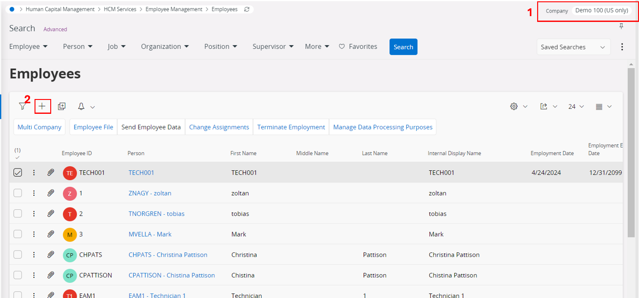

1. Select the relevant company
2. Click on the + icon to create a new employee
3. Fill the columns as follows
   1. Employee ID = <user input>
   2. Person = <same value as in employee id>
   3. First name = <User input>
   4. Last name = <User input>
   5. Internal Display Name = <first name><space><last name>
   6. Employment date = <user input, if that is null default value from IFS core logic>
   7. Employment End Date = <user input, if that is null default value from IFS core logic>
   8. Employment Type = <User input, if null ‘Full Time’>
   9. Organization = <User input>
   10. Position = <User input>

**Create Resources for Technicians/Drivers**  
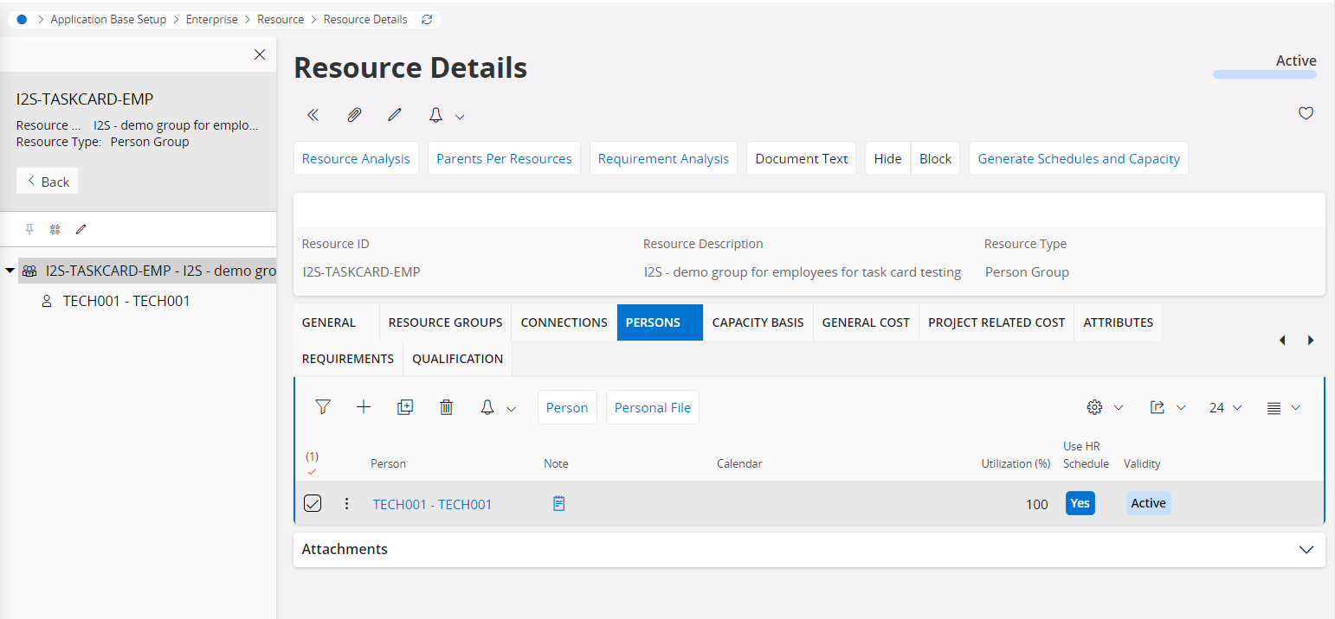

1. Go to Resource Details tab and search for Resource Group ‘I2S-TASKCARD-EMP’
2. Select Persons tab
3. Add a new line with above created person id
4. Select the new node created for new resource  
   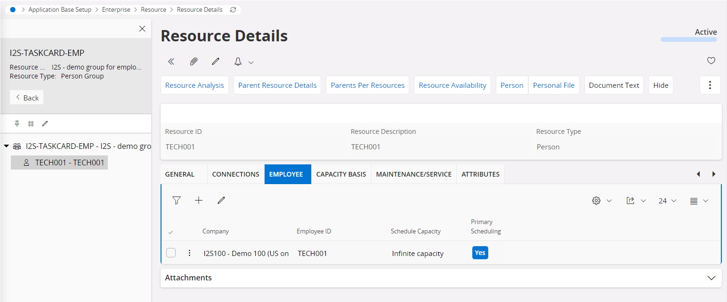
5. Under the Employee tab, add the above created employee
6. Select the Connection tab and create new connection for the given site  
   